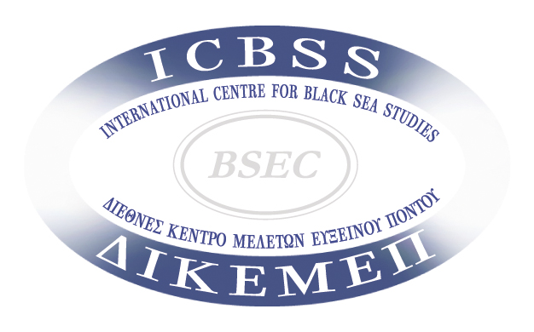

8th International Black Sea Symposium

on
“Science, Technology & Innovation in the Black Sea:
Moving Forward”
Athens, Greece
19-20 November 2015

APPLICATION FORM

Before completing this form, you are requested to read the IBSS Call. Please type text in English.

PERSONAL DETAILS

Title (Mr./Ms., PhD student, Dr., other)
First (given) name(s)∗
Last name(s) *
Sex (M/F)
Full address
Postal Code & City
Country
Email 1
Email 2
Contact Phone (incl. country code)
Mobile Phone (incl. country code)
Nationality
Date of Birth (dd/mm/yyyy)
Highest diploma/degree
Current occupation
STATEMENT OF PURPOSE

Please state what is your field of expertise / interests (200 words maximum):

ABSTRACT (for speakers only)

ADDITIONAL INFORMATION

Please specify how you found out about the 8th International Black Sea Symposium (e.g. name of website, ICBSS mailing, IBSS Alumni, notice board at university, etc.):

Thank you for your interest in the 8th INTERNATIONAL BLACK SEA SYMPOSIUM!

 Please state your name in Latin characters exactly as it is listed in your passport or internationally recognised ID document

