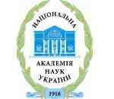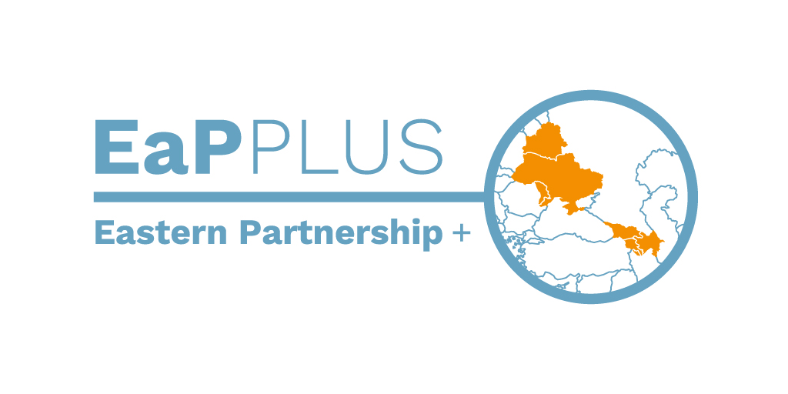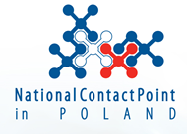

EaP PLUS | Horizon 2020 Info Day
Kyiv, 7 April 2017
National Technical University of Ukraine “Kyiv Polytechnic Institute”

Institution/individual PROFILE

ORGANISATION NAME

ORGANISATION TYPE | SME  Large Company | University  Research  Centre | Public  Administration  Other
CONTACT PERSON DETAILS:

Horizon 2020 areas of interests:
ENERGY
Energy Efficiency.
Competitive Low Carbon Energy.
Renewable Energy.
Energy System.
Smart Cities and Communities.
Transforming the energy sector through digitization.

ENVIRONMENT
Climate Action in support of the Paris Agreement.
Circular Economy.
Water for our environment, economy and society.
Innovating Cities for sustainability and resilience.
Raw Materials.
Protecting and valorising our natural and cultural assets.
Earth Observation.
Nature-based solutions, disaster risk reduction & natural capital accounting.
Heritage alive.

OTHER

Please specify the details of your interest/ project idea:

Profile of the Institution:

Match-making micro-meetings will be organized based on the profiles provided by the interested participants showing their area of interest and project idea. The match-making will be open to participants from EU and Ukraine.
