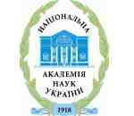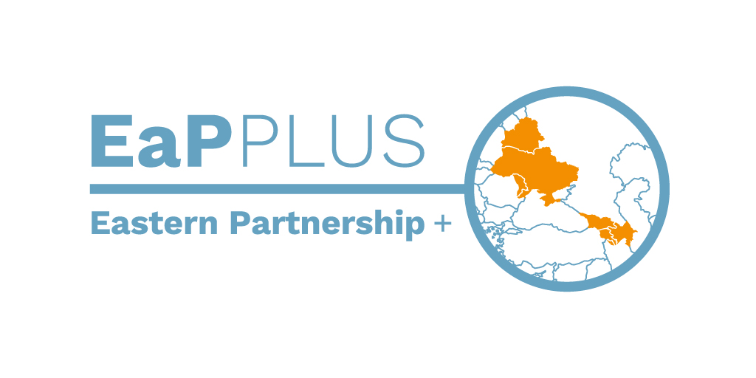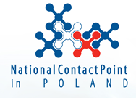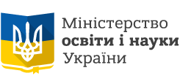

EaP PLUS | Horizon 2020 Info Day
7 April, 2017
Venue: Conference Room of Academic Board
of the National Technical University of Ukraine “Kyiv Polytechnic Institute”
Main building nr 1, Peremohy 37, Kyiv

AGENDA

8:45 – 9:00 Registration

9:00 – 9:10 | Welcoming – prof. Jurij Bobalo - Rector of the Lviv Polytechnic National University, prof. Jacek Namieśnik - Rector of the Gdańsk University of Technology
9:10 – 9:20 | EaP Plus project introduction – dr. Zygmunt Krasiński, Director of the Polish NCP for Research Programmes of the EU
9:20 – 9:50 | Horizon 2020: Introduction, main aspects – Olena Koval, National Information Center for Ukraine-EU S&T cooperation
9:50 – 10:25 | Energy: Topics, calls 2017, priorities in 2018-2020 - dr. Maria Śmietanka, Polish NCP expert
10:25 – 10:45 | Environment: Priorities in 2018-2020 - dr. Magdalena Głogowska, Polish NCP expert

10:45 – 11:00 Coffee break

11:00 – 11:20 | Horizon 2020 project evaluator: project writing concerns and hints - Piotr Dymarski, Mostostal Warszawa S.A.
11:20 – 11:40 | H2020 success story - Dr. Jacek Gajewski, National Centre for Nuclear Research, Poland
11:40 – 12:00 | H2020 success story - Dr. Tetiana Zheliezna, Head of the General Bioenegry Issues Department, Scientific Engineering Centre "Biomass" Ltd. (SECB), Ukraine

12:00 – 12:20 Coffee break and regrouping for match-making

12:20 – 14:00 | Match-making micro-meeting and consultations with NCP experts

