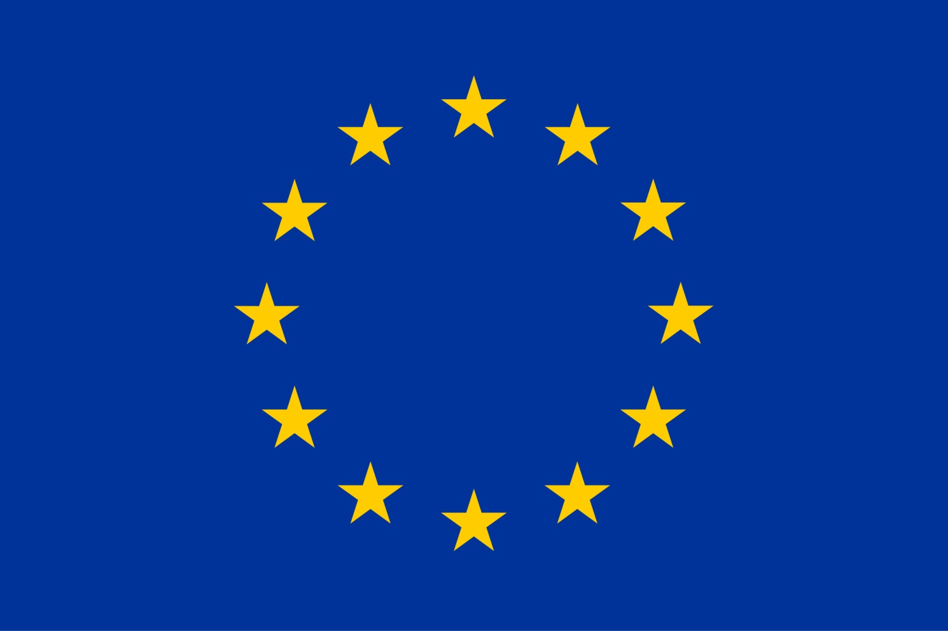
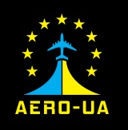

AERO-UA Travel Grants for Ukrainian aeronautics community
Promoting Aerospace Research Collaboration between the European Union and Ukraine
The AERO-UA (www.aero-ua.eu) project’s purpose is to promote Europe-Ukraine research collaboration in the aerospace field. One of the AERO-UA specific objectives is to increase the range and number of Ukrainian organisations involved in aeronautics proposals for H2020 and Clean Sky 2. For that end, the project announced the first open call for Ukrainian aeronautic actors to receive the grants for travelling to EU countries.
The First Call for Applicants for AERO-UA Travel Grants was opened on 19 April 2017 with the deadline on 31 July 2017. Applications will be evaluated on the first come - first served basis.
Please, note: the number of grants is limited!
Travel grant in a maximum of €900 will be awarded for one of the following travel purpose:
- to meet with European partners during aeronautics-related proposals preparation ,
- to attend thematic info-days and brokerage events organized by the European Commission,
- to present research results at conferences or trade-shows within the European Union.
Eligible applicants are individuals working in aerospace field from Higher Education Establishments, Research Institutions or Companies (including SMEs) duly registered in Ukraine.
Travel Grant Rules and Guidelines as well as the Application Form are published at the AERO-UA project website http://www.aero-ua.eu/first-call-for-applicants-for-travel-grants.html
To apply for a travel grant, please, fill in the form below and send it together with other supporting documents listed in the AERO-UA Travel Grant Rules to:
Giles Brandon
AERO-UA Project Coordinator
E-Mail: contact <at> intelligentsia-consultants.com
Please, mention „AERO-UA Travel Grant Application“ in the email subject line.
In Section 2 you have to fill in only ONE subsection relevant to your selected purpose of travel.
Deadline for submitting travel grant application form: 31 July 2017

Section 1. Personal Profile
First Name
Last Name
Organisation Name
Web-link to the organisation website
Department
Position
Email address
Phone number
Address
Street Address and Number
City
Postal Code

Section 2. Purpose of Travel Grant Application
Please select one (1) of the reasons for your trip from the table below (scientific conference, trade-show, research project or networking) and provide the required information.
1. Project Proposal Meeting
Potential proposal title
Potential funding source (Horizon 2020, Clean Sky 2)
Call name (including link)
Short description of the project proposal (max 2000 characters)
Confirmed consortium partners (names & locations)
Dates (of travel)
Meeting Location (city & country)
2. EC info-days, thematic brokerage events
Name of event
Web-link to the event
Dates (of travel)
Meeting location (town & country)
3. Scientific Conference or workshop
Name of conference/workshop
Event web-link
Location (city & country)
Dates (of travel)
Title of the research paper or poster to be presented at the conference
4. Trade-Show or Exhibition
Name of Trade-Show or Exhibition
Trade-Show or Exhibition web-link
Location (city & country)
Dates (of travel)
Explain how your research results will be presented (booth, poster, etc.?)

Section 3. Estimated travel costs
Please, estimate travel costs in Euro
Travel, €
Accommodation, €
Event Fees, €
Other costs, €
Total Estimated Costs, €

Section 4. Expected Outcomes and Benefits of this Trip
Please describe in concrete terms the expected outcomes and benefits from your trip, in relation to promoting aerospace research collaboration between the European Union and Ukraine. (Max: 400 words).

Section 5. How did you hear about this Travel Grant?
Please indicate how you found out about this travel grant opportunity.
AERO-UA web-site
Other web-site
AERO-UA promotional materials (leaflet, poster)
E-mail newsletter from AERO-UA partner
During AERO-UA event
During other event (please, specify)
Social network
From partner / colleague
Other (please, specify)

